Station 1 – Cohesion
In your bio notebook: Copy notes, complete demo/record observations & answer q’s. Notes: Cohesion is caused by the intermolecular attraction between like-molecules within a body or substance that acts to unite them. So it’s how sticky the molecules are to each other. Water has a high attraction to other water, so water has high cohesive properties. This allows water to be pulled along a pathway with relative ease. An example would be our blood being pumped through our body and the cohesiveness of the cytoplasm in the cells.

Demonstration Instructions
1. Use the dropper to place 20 drops of water onto the penny.
2. Observe what happens (put your eyes level to the table to observe)
3. Poke the water on the penny with the end of the toothpick, and observe.
4. Dip the toothpick in soap and now poke the water with it, observe what happens.
5. Rinse and dry off the penny. Throw away the toothpick.

Questions

1. How did water show cohesion when you put twenty drops on the penny?

2. Look up hydrogen bonds in the text (p 40) and summarize what it means.

3. Soap breaks the hydrogen bonds of water. How does the breaking of hydrogen bonds affect the cohesion of the water?

4. Explain how the image below connects to the concepts in this station:

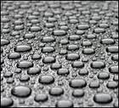

Station 2 – Adhesion
In your bio notebook: Copy notes, complete demo/record observations & answer q’s.
Notes: Adhesion is any attraction process between dissimilar molecular species. Adhesion is the tendency of dissimilar particles and/or surfaces to cling to one another. Water is very adhesive. So water will “stick” to many other molecules (especially other polar molecules). Water is not adhesive towards non-polar molecules such as oils or fats.
Demonstration Instructions
1. Lower the wax paper into the water so that about 2 cm is submerged under the water
2. Hold the wax paper still in this position for 60 seconds.
3. Observe whether water has adhesive properties with wax paper or not.
4. Repeat this experiment with paper towel.

Questions
1. What does water have more adhesion towards, wax paper or paper towel? Which material is polar and which is non-polar?

2. Plants would not be able to get water from their roots to their upper sections without adhesion and cohesion. Explain how adhesion and cohesion allow plants to “pull” water up from their roots. (See page 41)

3. According to the text, how is adhesion caused by hydrogen bonds (see page 40)?

4. Explain how the image below connects to the concepts in this station:

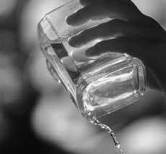

Station 3 – High Specific Heat
In your bio notebook: Copy notes, complete demo/record observations & answer q’s.
Notes: Water has a high heat capacity. This means that water can absorb or release a lot of energy with only a small change in temperature. Water’s high heat capacity is due to hydrogen bonding. This is why water is valuable to industries and in your car's radiator as a coolant. The high heat capacity of water also helps regulate the rate at which air changes temperature, which is why the temperature change between seasons is gradual rather than sudden, especially near a lake or ocean.

Demonstration Instructions
(CAUTION: THE HOT PLATE WILL BURN YOU IF YOU TOUCH IT. SO DON’T!!)
1. Check and make sure that both flasks have 50 ml of liquid.
2. Place the digital thermometers inside the beaker of water and place the beaker on the hot plate for 4 minutes using the neulog program (ask Mr. C for help setting up the experiment).
3. Record the temperatures of the sample every 30 seconds onto a data table.
4. Repeat the experiment using the beaker of vegetable oil.
5. Plot the data you collect on a double line graph.
Questions
1. What has a higher heat capacity, water or vegetable oil?
a. How does the experiment show this?
2. Our body is 70% water, and has the ability to survive in very hot and very cold environments. What would happen to our bodies in hot weather if water didn’t have high specific heat?
3. How does hydrogen bonding explain the high heat capacity of water (see page 41)
4. Explain how the image below connects to the concepts in this station:

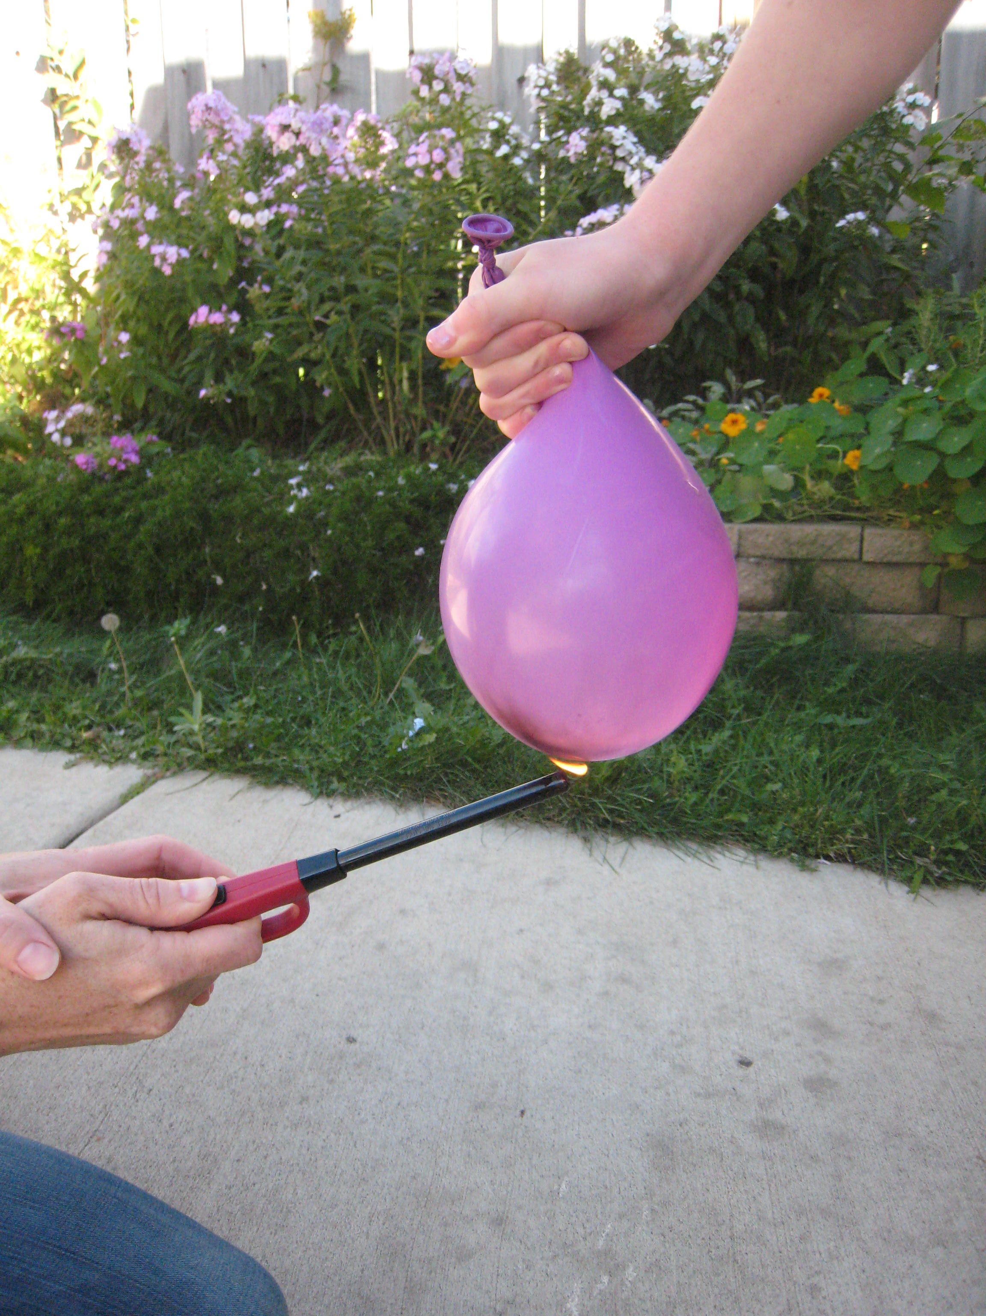

Station 4 – Surface Tension
In your bio notebook: Copy notes, complete demo/record observations & answer q’s. Surface tension is a property of the surface of a liquid that allows it to resist an external force. Some objects can float on the surface of water, even though they are denser than water. Surface tension allows some insects (e.g. water striders) to run on the water surface. This property is caused by cohesion of like molecules, and is responsible for many of the behaviors of water.

Instructions
1. Use a plastic fork to gently lower the paper clip onto the top of the water.
2. Carefully remove the fork from underneath the paperclip without the paperclip sinking (this may take several tries)
3. Try to repeat this with the alcohol. Will the paperclip float on alcohol?
4. Remove both paperclips before the next group arrives
5. Write down your observations.

Questions

1. What property of water allowed the paperclip to float?

2. How do hydrogen bonds explain this property of water?
3. Explain how the image below connects to the concepts in this station:

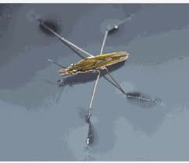

Station 5 – Dissolving a Solute
In your bio notebook: Copy notes, complete demo/record observations & answer q’s.
A solution is a type of mixture where one material dissolves in another. The material that dissolves is called the solute. The material that does not dissolve is called the solvent. Water is sometimes called “the universal solvent” because it has the ability to dissolve many different things.

Instructions
1. Add one spoonful of salt into the water and observe what happens to the solution.
2. Now stir the solution with the spoon and observe.
3. Repeat this with the alcohol solution
4. Write down your observations.
Questions
1. In this experiment, identify the solvent, solute and solution
2. What happens to the NaCl molecules when salt dissolves in water (see page 40)?
3. Not everything will dissolve in water. According to page 40, what types of molecules can dissolve in water and what types cannot?
3. Explain how the image below connects to the concepts in this station:

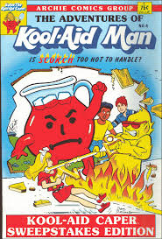
Station 6 – Density of Ice
In your bio notebook: Copy notes, complete demo/record observations & answer q’s.
Another amazing property of water is that it expands as it freezes and contracts as it melts. Almost everything else in nature contracts when it freezes and expands when it melts. Since the same amount of water takes up more space in the form of ice, ice has less density than water.

Instructions
1. Make a prediction about what will happen when ice is put into the water and into the alcohol
2. Drop an ice cube into the water and the alcohol.
3. Write down your observations.

Questions

1. Why did the ice behave the way that it did? (Hint: talk about its density compared to water and alcohol in your answer)
2. In the winter, does a lake freeze from the top down or the bottom up? Why is this important for plants and animals that live in lakes?
3. According to the text on page 42, how does hydrogen bonding explain this property of water?
4. Explain how the image below connects to the concepts in this station:



