SECTION 20–1, 20-1 REVIEW
MULTIPLE CHOICE Write the correct letter in the blank.
1. An example of mimicry that is important in anti-predator defenses is when
a. a harmless species resembles a dangerous species.
b. two harmless species look similar.
c. a species resembles an inedible object.
d. one individual uses bright colors to warn others of danger.
2. One difference between predators and parasites is that parasites
a. usually do not cause the immediate death of the organism they feed on.
b. feed only on the inside of other organisms.
c. are always microorganisms.
d. are not anatomically or physiologically specialized.
3. Magpies and crows are scavenger birds that feed on the same food sources and cannot live in the same community. This is an example of
a. character displacement. c. symbiosis.
b. resource partitioning. d. competitive exclusion.
4. A change in anatomy that results when two species compete for the same resource is called
a. mutualism. c. competitive exclusion.
b. character displacement. d. resource partitioning.
5. A symbiotic relationship in which one species benefits and the other is not affected is called
a. commensalism. b. mutualism. c. parasitism. d. competition.
6. The measure that relates the number of species in a community to the relative abundance of each species is called
a. species richness. c. community stability.
b. species evenness. d. community interaction.
7. One explanation for the greater number of species in the Tropics than in temperate zones is that
a. tropical habitats are younger than temperate habitats.
b. there is more energy available to support more organisms in the Tropics.
c. people have been cultivating species for much longer periods in the Tropics.
d. the climate is more stable in temperate habitats.
8. The stable end point of succession is called
a. staged community. c. climatic change.
b. climax community. d. community development.
SHORT ANSWER Answer the questions in the space provided.
1. How are secondary compounds useful to plants?

2. What is the difference between the fundamental niche of a species and the realized niche of the species?

3. Why does primary succession often proceed very slowly?

4. How does species richness vary with latitude?

5. Critical Thinking A biologist finds that when two species of paramecia are grown together in the laboratory, one species always outcompetes and eliminates the other. In ponds and other natural environments, however, the two species coexist. Suggest a hypothesis to explain this phenomenon.

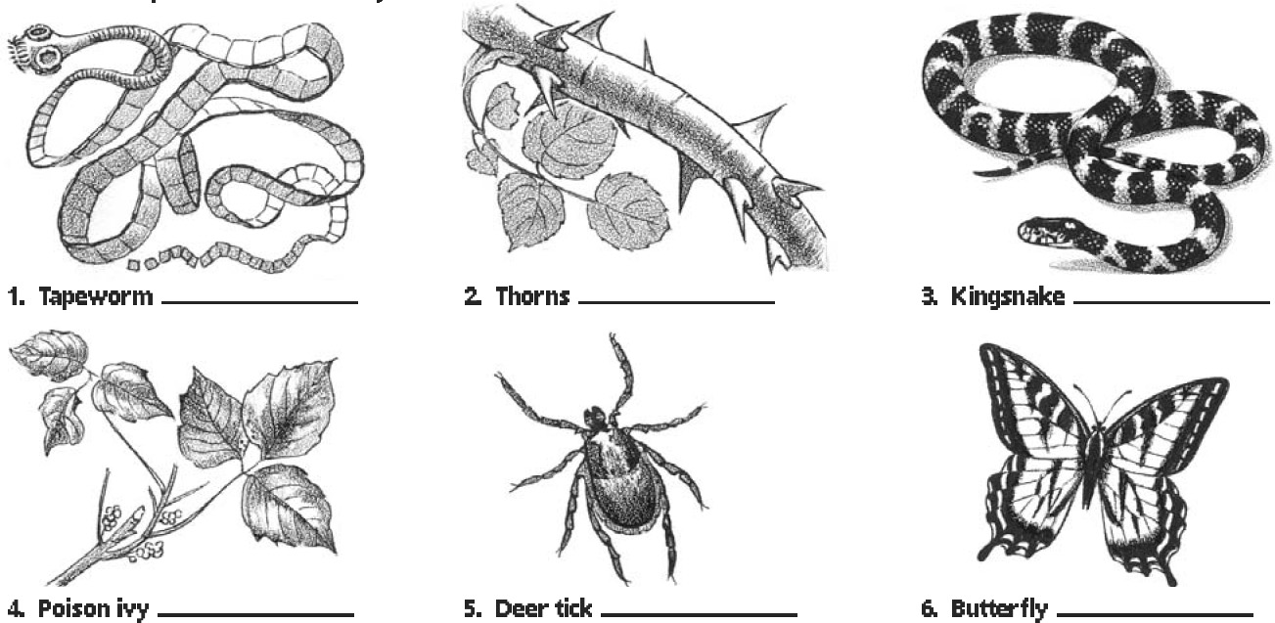
STRUCTURES AND FUNCTIONS Label each drawing below with the most appropriate term from the following list: pollinator, physical defense, secondary compound, endoparasite, ectoparasite, mimicry.

