Sex-linked Characteristics NOTES AND CFU BLAST!
Review Problem: Dominant/Recessive
- Huntington disorder is a progressive degeneration of the nervous system that begins at middle age and results in an early death. It is caused by a single autosomal gene mutation that acts in a dominant fashion. (Use the letter “H” to represent the Huntington’s allele)
- A 40 year old man was just diagnosed with Huntington disorder. What could his genotypes be? _________________________
- His wife went for genetic screening for the Huntington allele and learned that she did not have it. What is her genotype? __________________
- Assume it was determined through genetic screening that the husband only had one copy of the Huntington allele. What must his genotype be? __________________
- Draw a Punnett square to determine their children – circle the children with the Huntington allele.

GENOTYPES:
Genotypic ratio:

PHENOTYPES:
Phenotypic ratio:

- They have a 12 year old son. What is the chance that he inherited the disorder? _______
- Now assume it was determined through genetic screening that the husband had two copies of the Huntington allele… now what must the son’s genotype be? ____________

Key Words and such…

- Autosome _____________________
- Autosomal inheritance = dominant/recessive etc.
- Sex chromosomes = X and Y chromosomes

- Females have _________
- ______________ have XY

Genetics and Abnormalities

- Genetics is the study of heredity.
- Heredity is how different genes _________________________________________________.
How are genes passed down from parents to children?
- DNA is stored in our bodies’ ___________. Genes can be found on _______________. A normal chromosome carries 1,000 or more genes. In our bodies, chromosomes are found in pairs.
- Chromosomes carry genetic information (DNA) that is passed down from __________________________. Cells need DNA to provide directions that allow the cell ____________________________.

MOM
DAD
- When an egg is fertilized by a sperm, the resulting embryo gets ___ of its chromosomes from its mother and ___ its chromosome from its father.
- The genetic information in these chromosomes provide directions for making a baby with certain characteristics.
- 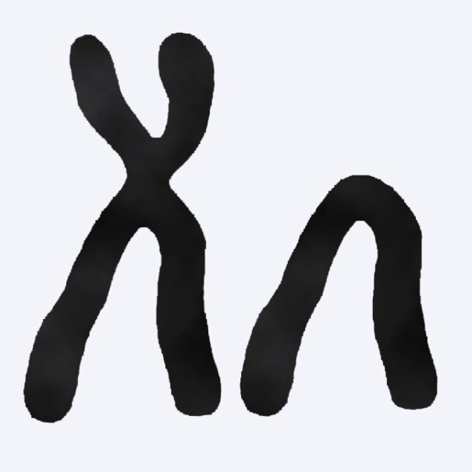Humans have 23 pairs of chromosomes-46 total chromosomes. A human being inherits 23 chromosomes from their mother and 23 chromosomes from their father. The 23rd chromosome is the chromosome that determines whether ____________________________. -Label the diagrams of the chromosomes
- _____________, your 23rd pair of chromosomes look different, XY.

- 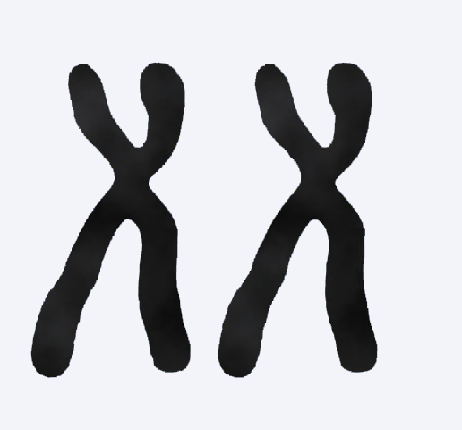If you are female, your 23rd pair of chromosomes look the same, ____.

CFU Problem:
- How many genes are on a typical chromosome? ________
- What percentage of your chromosomes comes from your Mom? What percentage comes from your Dad? Mom:_________ Dad:_________
- Draw a Punnett Square for the 23rd chromosome:
GENOTYPES:

Genotypic ratio:

PHENOTYPES:
Phenotypic ratio:

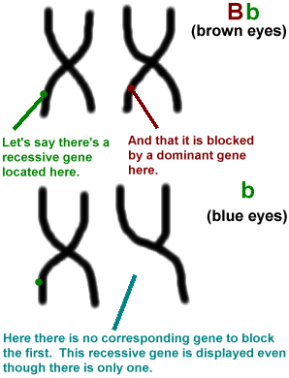
Sex-linked traits!
Are inherited by means of sex chromosomes (X, Y)
- In __________________________, particularly x-linked, males typically display the phenotype, although it is possible for females to express the phenotype as well.
________ experience a greater effect of sex-linked traits due to having only one x-chromosome, whereas ____________ have two.

Sex-Linked Disorders
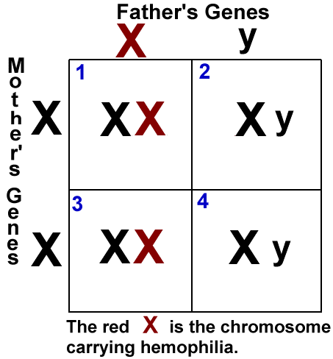
- Certain _________________ (red-green) is a sex-linked (x-linked) genetic disorder
- Hemophilia is a sex-linked genetic disorder
- 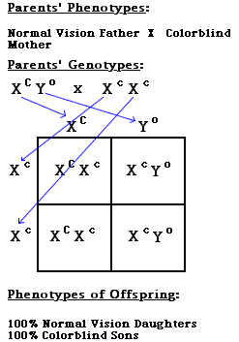Fragile-x syndrome is inherited by means of sex-chromosomes

Sex-linked Recessive Traits
.
- General statements for the pattern of inheritance of X-linked recessive traits or diseases:
  - Two people without the disease (or trait) can _____________________________ (trait).

  - The disease (trait) often skips several generations before __________________.

  - The disease (trait) _________________________ more often than girls.

CFU #2: Sex-linked recessive traits
Red-green colorblindness is caused by a recessive allele of a gene on the X chromosome. Suppose a normal man and a woman who is a carrier (heterozygous) for colorblindness have children. Note C = normal vision allele; c = colorblind allele
- Complete the Punnett square

GENOTYPES:
Genotypic ratio:

PHENOTYPES:
Phenotypic ratio:

CFU #2 continued: hemophelia
- Hemophilia, the inability of blood to clot, is caused by a recessive mutation of a gene on the X chromosome. Suppose a normal man and a woman who is a carrier for hemophilia have children. Complete a Punnett square to show the possible types of children .

GENOTYPES:

Genotypic ratio:

PHENOTYPES:
Phenotypic ratio:
- What is the chance that they have a hemophiliac child? _________
- What sex will the hemophiliac child always be? ___________
- At the hospital, just after their baby boy is born, the doctor informs them that there is a __________ chance that their boy is a hemophiliac.
CFU #2 – Final Questions!
- For X-linked recessive mutations, what genotypes must the parents be in order for a female to inherit the trait or disorder? Mom: _________________ Dad: _________________
- In order for a woman be hemophiliac or colorblind, what must be her parent’s genotypes?

